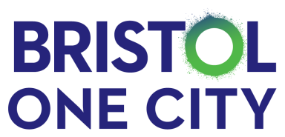
Bristol One City Culture Board
Date/time | 17 04 24 2 – 4 pm |  | Venue | The Mill Room, St Anne's House, St. Anne's Road, Brislington, BS4 4AB
Co-Chairs | Cllr. Craig Cheney – Deputy Mayor and Cabinet Member for Finance, Governance and Performance  Charlotte Geeves - Executive Director and Joint CEO of Bristol Old Vic
Pre-reading | Report - One City Goals
Agenda
2 – 2.10 pm  10 mins |  | 1. Welcome & Introductions  Welcome to Philip Walker – Head of Culture, Bristol City Council |  | Charlotte Geeves – Co-Chair
2.10 – 2.15  5 min |  | 2. Actions from Culture Board – 17 01 24 |  | Karen Blong – City Office
2.15 - 2.20pm  5 mins |  | 3. City Office Update  - City Gathering |  | Karen Blong – City Office
2.20 – 2.25 pm  5 mins |  | 4. Update on Goal 58:  Gender, race, ethnicity and disability pay gaps are decreasing due to improved skills pathways and mentoring with routes to access senior employment opportunities (part-time and flexible) |  | Karen Blong – City Office
2.25 – 2.45 pm  20 mins |  | 5. Good Employment Charter |  | Toby Howkins - Business Growth & Enterprise Project Manager  West of England Combined Authority
 |  | Comfort Break 2.45 – 3.00 pm
3.00 – 3.40 pm  40 mins |  | 6. Culture Strategy for Bristol |  | Charlotte Geeves – Co-Chair
3.40 – 3.50 pm  10 mins |  | 7. Economic and Social Value impact questionnaire – update on progress. |  | Elise Hurcombe, Art Development Manager
3.50 – 4pm  10 mins |  | 8. Any Other Business |  | All

