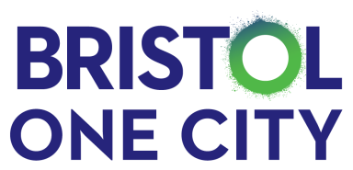
Bristol One City Children & Young People’s Board

Date/time |  | 22/03/2021 @ 4pm – 6pm | Venue | Zoom Call
Co-chairs |  | Councillor Helen Godwin  John Wayman and Alice Towle
Agenda
1) | Update from the Chair – Cllr Helen Godwin
2) | Belonging Strategy – Alison Hurley & Ann James
3) | Digital Inclusion – John Bradford
4) | Youth Transport – Youth Mayor John Wayman
5) | Holiday Activity and Food Fund – Tommy Jarvis
6) | One City Board Links – Cllr Helen Godwin
5) | AOB and close

